 Key BMI088 Parameters from Datasheet

**Accelerometer (Table 4):**

* Measurement Range: ±24g (Register 0x41: acc_range=0x03)
* Sensitivity: 1365 LSB/g (±24g range)
* Noise Density: 190 μg/√Hz (Z-axis, ±3g range - conservative estimate)
* Bias Instability: 0.5 mg
* Output Data Rate: 100 Hz (Register 0x40: acc_odr=0x08)

**Gyroscope (Table 5):**

* Measurement Range: ±2000°/s (Register 0x0F: gyro_range=0x00)
* Sensitivity: 16.384 LSB/°/s (±2000°/s)
* Noise Density: 0.1 °/s/√Hz
* Bias Instability: 10 °/h
* Output Data Rate: 400 Hz (Register 0x10: gyro_bw=0x03)

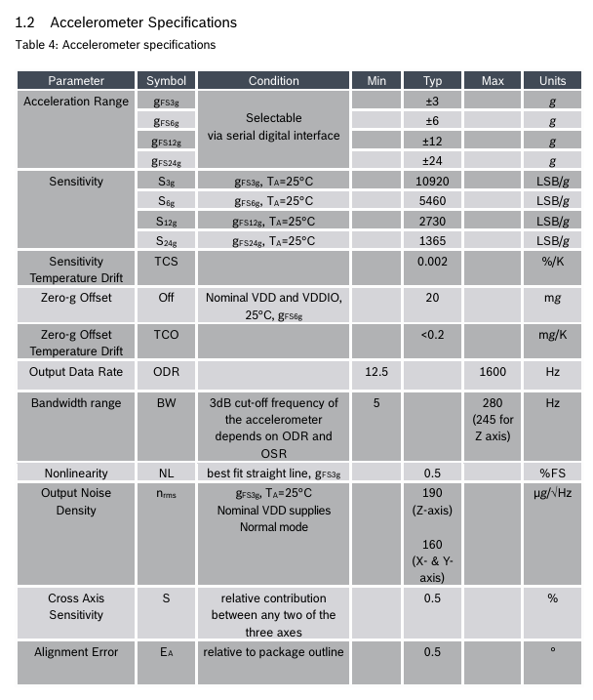

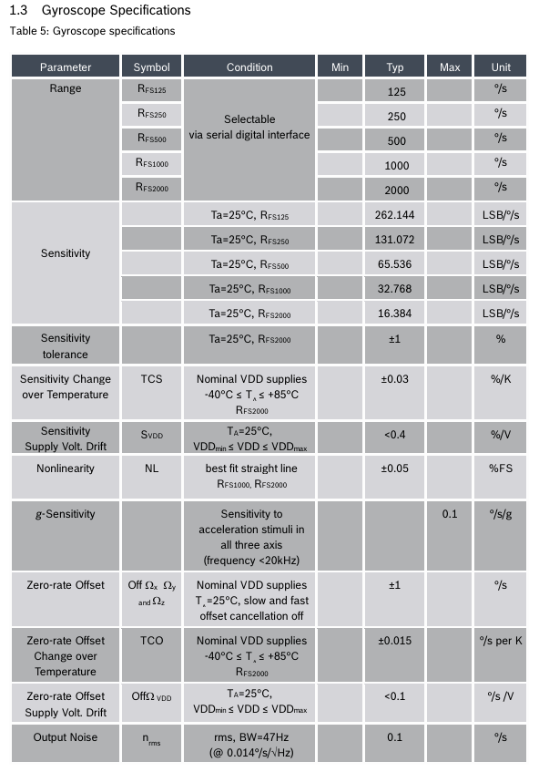

**Temperature Sensor (Table 6):**

* Resolution: 0.125 °C/LSB
* Offset Error: ±1°C at 25°C

***Numerical used in code***

**Accelerometer**

1)**Measurement Range:**

* Datasheet: ±24 g (so full-scale is 24 × 9.81 m/s²).
* In code: MeasurementRange = 24*9.81 sets that exact numeric range (≈ 235 m/s²).

2) **Resolution:**

* BMI088 has a 16-bit ADC for accel. Full-scale = ±24 g ⇒ 2^16 counts across 48 g.
* So 1 LSB = (48 g · 9.81 m/s²) / (2^16) = (48 × 9.81)/(65536).
* code does: 2 * 24 * 9.81 / (2^16) → same thing: 48·9.81/65536 ≈ 0.00718 m/s²/LSB.

3) **Noise Density:**

* Datasheet: 190 μg/√Hz.
* Convert micro-g to m/s²: 190 × 10⁻⁶ g/√Hz × 9.81 m/s²/g = 190e-6 × 9.81 ≈ 0.001864 m/s²/√Hz.

4)**Constant Bias (Bias Instability):**

* Datasheet: ~0.5 mg bias instability. That’s 0.0005 g.
* In code: [0.5e-3, -0.5e-3, 0.5e-3] * 9.81 → around ±0.0049 m/s² biases in X, Y, Z.

**5)Axes Misalignment:**

* Small angles (in radians) to simulate a tiny tilt/misalignment on each axis.

**Gyroscope**

1)**Measurement Range:**

* Datasheet: ±2000 °/s for gyro.
* In code: MeasurementRange = 2000 means ±2000 °/s.

2) **Resolution:**

* A 16-bit ADC over ±2000 °/s gives 4000 °/s total span across 2^16 counts.
* So 1 LSB = 4000 °/s ÷ 65536 ≈ 0.061 °/s.
* code writes 2 * 2000 / 2^16 = (4000/65536) ≈ 0.061 °/s per LSB.

3) **Noise Density:**

* Datasheet: 0.1 °/s/√Hz.
* Code: NoiseDensity = 0.1 leaves it in °/s/√Hz (MATLAB will internally convert to rad/s/√Hz if needed).

4) **Constant Bias:**

* Datasheet: Bias instability ~10 °/h. Convert to rad/s: 10 °/h = 10 ° / 3600 s = (10 × π/180)/3600 ≈ 4.85 × 10⁻⁵ rad/s.
* Code: [10, -10, 10] * (pi/180/3600) applies that on each axis (with signs).

5) **Axes Misalignment:**

* Same small tilt in radians, just like the accel.

**Output**

